**cp command:**



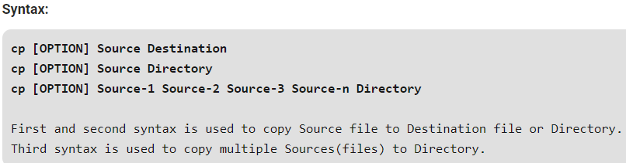

cp command works on three principal modes of operation and these operations depend upon number and type of arguments passed in cp command

**Two file names:**

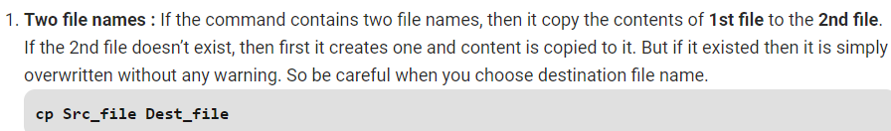

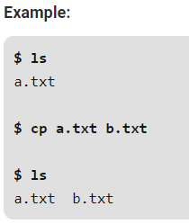

**One or more arguments:**

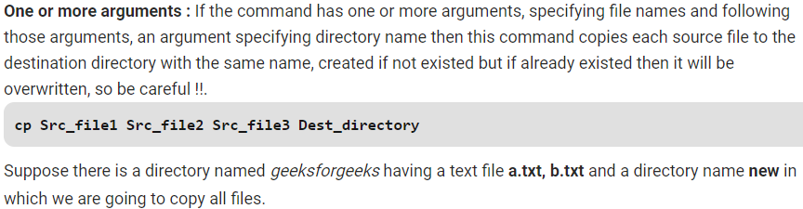

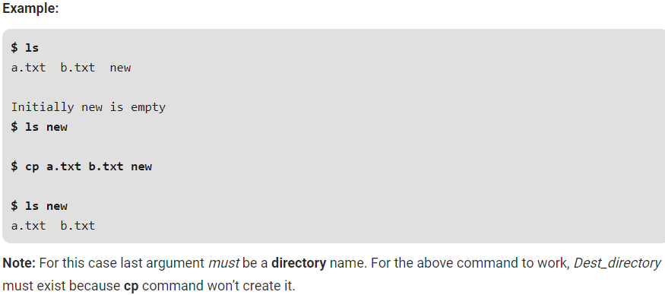

**Two directory names:**

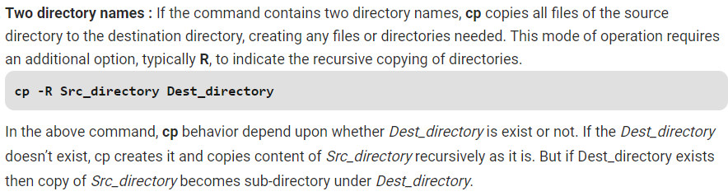

**Options:**

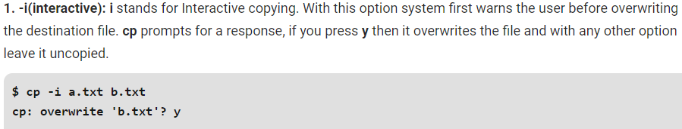

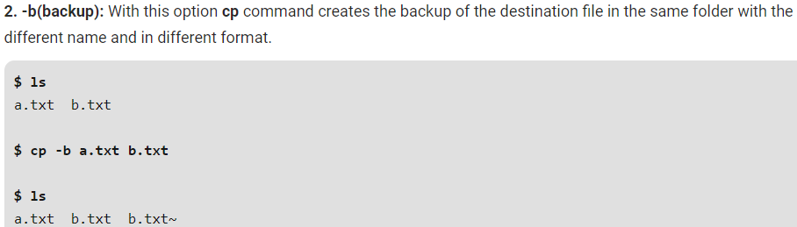

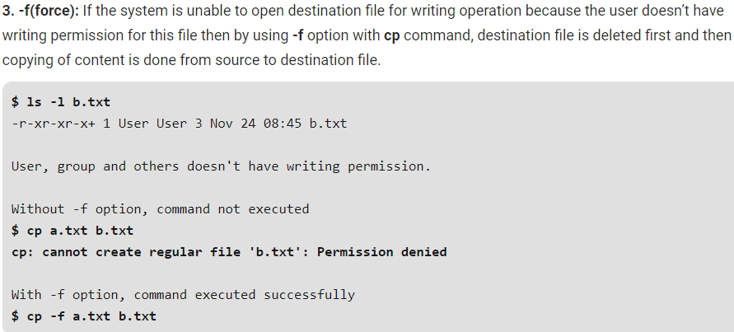

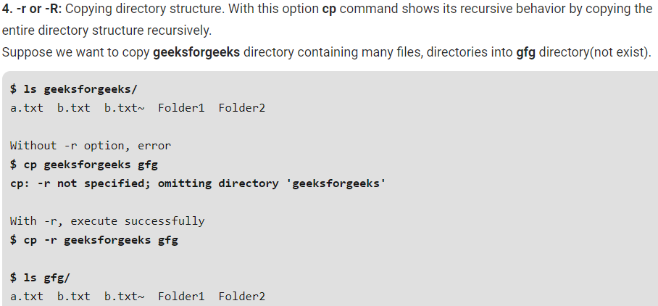

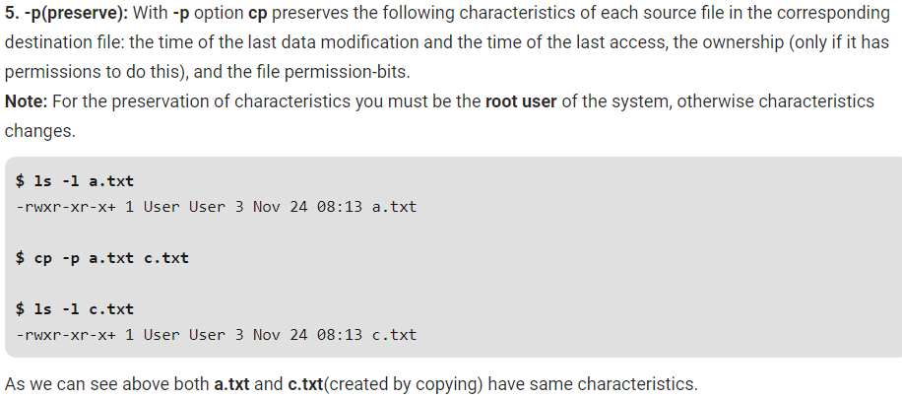

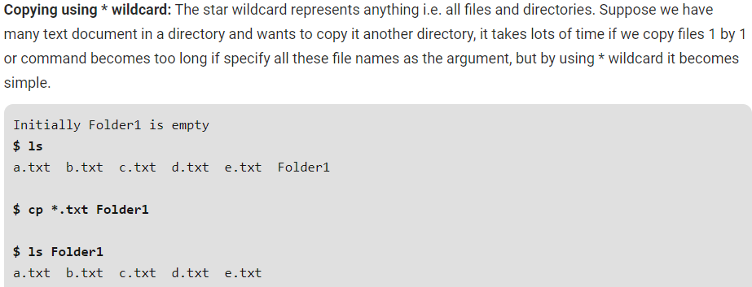

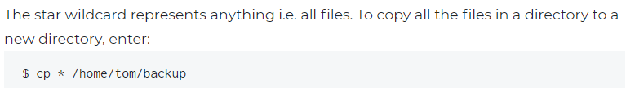

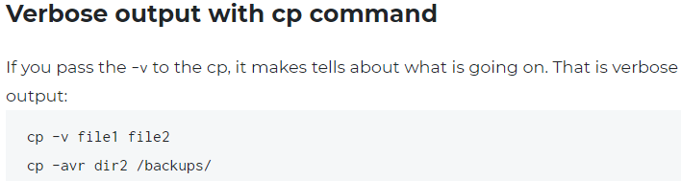



**mv command:**

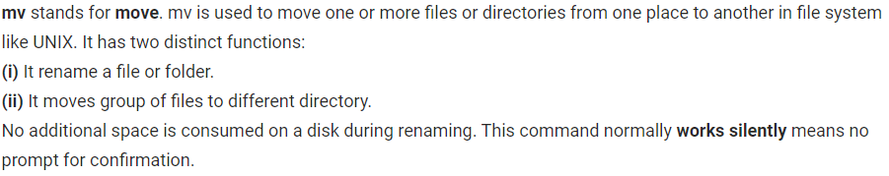

* In order to move a file, you need to have permission to detach it from the directory where it was before, and to attach it to the directory where you're putting it. In other words, you need write (and execute) permission to both the source directory and the destination directory. You do not need to have any particular permission on the file, since you aren't modifying or accessing the file itself. (Analogy: you can move a locked box around even if you don't have the key do open the box.)

To rename the file

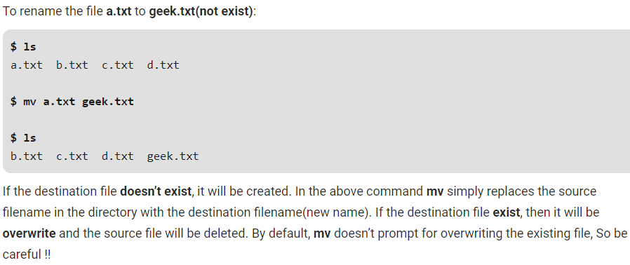

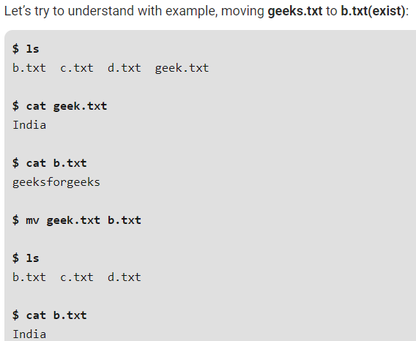

If we give any existing file as destination, then the source file data will be overwritten in destination file as above

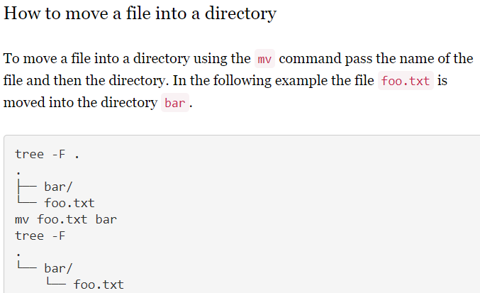

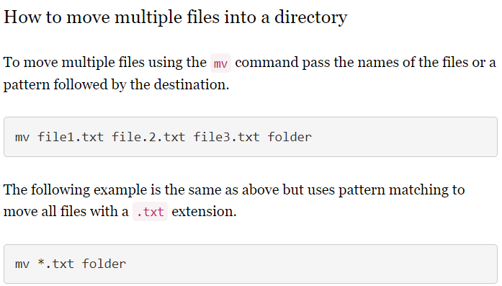

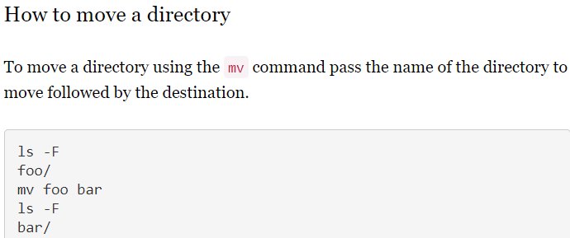

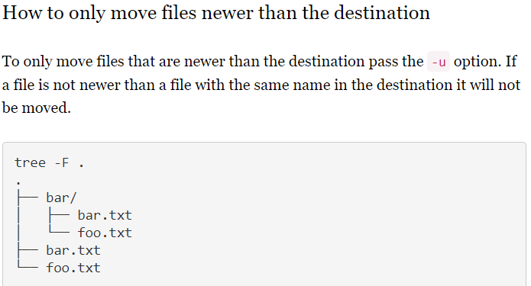

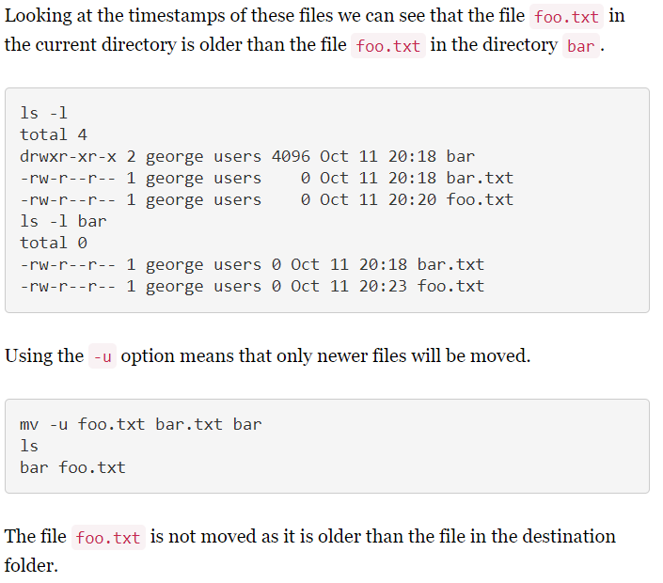

**Options:**

**-i (Interactive):** Like in cp, the -i option makes the command ask the user for confirmation before moving a file that would overwrite an existing file, you have to press y for confirm moving, any other key leaves the file as it is. This option doesn’t work if the file doesn’t exist, it simply rename it or move it to new location.

**-f (Force):** mv prompts for confirmation overwriting the destination file if a file is write protected. The -f option overrides this minor protection and overwrite the destination file forcefully and delete the source file.

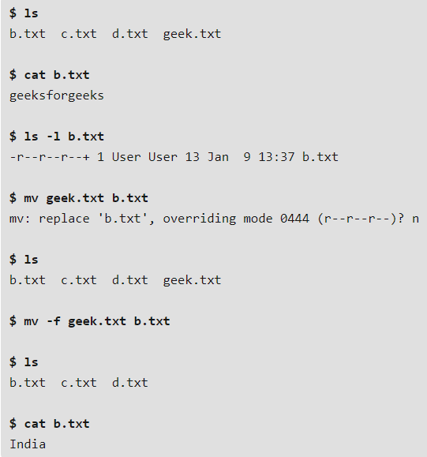

**-n (no-clobber):** With -n option, mv prevent an existing file from being overwritten. In the following example the effect is for nothing to happen as a file would be overwritten.

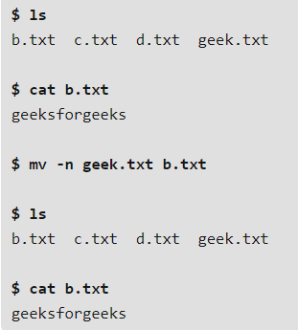

**-b(backup):** With this option it is easier to take a backup of an existing file that will be overwritten as a result of the mv command. This will create a backup file with the tilde character(~) appended to it. This works just like cp command

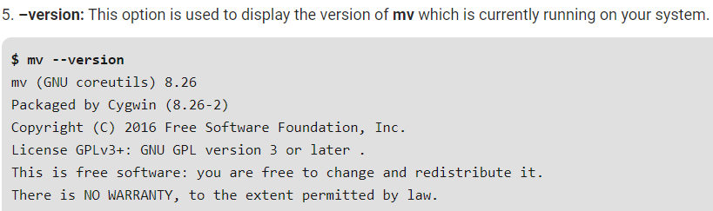

There is no need of “-r” option in mv command to move a directory.

**Overwrite:**

Copy and move commands by default overwrites the data in destination path. If there are any extra files in destination path are not in source path, then it won’t touch those files. That files will not be removed.

If we want to not overwrite any files or data inside it if the files are already existing. Then we need to use **“-n”** option in cp or mv command as below.

* **cp -n file1.txt /tmp/**
* **mv -n new/ /tmp/**

**note:**

**we can’t do exclude in cp or mv command. We can use rsysc or fine command for that.**

**Looks like we need root access to use preserve copy to set the ownership and all.**